- ALWAYS REFER “mavenrepository” FOR THE DEPENDENCIES.
- Spring AI is a Spring Boot abstraction layer that lets your Java app talk to AI models (LLMs) like OpenAI, Azure OpenAI, Ollama, HuggingFace, etc.
  - You do NOT write raw OpenAI REST calls.
  - You do NOT manage prompts manually everywhere.
  - You do NOT bind your code to one AI vendor.
- Spring AI doesn’t create models; It connects to existing models;
- Dependencies of Spring AI
  - spring-ai-bom (version control)
    - Keeps all Spring AI modules on compatible versions
    - Prevents dependency conflicts
    - Nothing functional; only dependency management.
    - Inside this you can see something like this
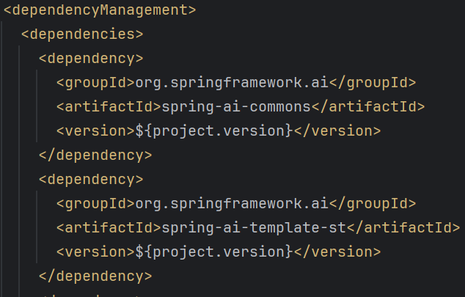
  - spring-ai-client-chat (chat API abstraction)
    - Gives you ChatClient
    - Unified way to send prompts & get responses
without this, no chat with LLMs.
  - spring-ai-model (model contract layer)
    - Defines interfaces like ChatModel, EmbeddingModel
    - Makes providers interchangeable
This is the brain of Spring AI.
  - spring-ai-starter-model-openai (OpenAI integration)
    - Auto-configures OpenAI client.
    - Reads API key, model, temperature from properties
without this, Spring AI doesn’t know OpenAI exists.

ChatModel vs ChatClient vs EmbeddingModel
- OpenAI provides Chat models and Embedding models
these both does separate things.
  - You can use: chat only, embedding only or both (RAG).
  - ChatClient/ChatModel handle text generation, EmbeddingModel handles vectorization; they are architecturally and functionally independent in Spring AI.
  - Vectorization is required to perform semantic search over large text corpora; ChatClient only generates text and cannot retrieve or rank information, so embeddings convert language into a numeric space where similarity can be computed.
    - For example think over a large pdf and you asked some question related to the context at some page.
    - here, vectorization is used to find the most related topic of your search.
    - All keywords are represented with a number, and numbers having smallest distance between then are chosen to be related.
    - Now after finding the related content, chat client is used for text generation.
    - 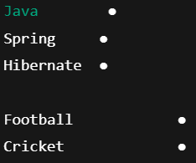
- ChatModel
  - Lowest level (actual LLM wrapper)
  - What it is?
    - Interface over the real LLM
    - One implementation per provider (OpenAI, Ollama, Claude …)
  - What is does?
    - Sends request to model
    - Gets raw response
    - No memory, no prompt templates, no tools
  - Analogy: this is Engine.
  - Example
- ChatClient
  - Developer-friendly facade over ChatModel
  - What it is?
    - High-level API built on top of ChatModel
    - This is what YOU should use in apps
  - What it adds?
    - Prompt building
    - System / user messages
    - Advisors (memory, RAG, tools)
    - Fluent API
  - Analogy: This is the steering wheel + dashboard.
  - Example
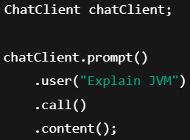
- EmbeddingModel
  - Text → Vector converter
  - What it is?
    - Separate model type
    - NOT for chatting
  - What it does?
    - Converts text into numerical vectors
    - Used for RAG / semantic search
  - Analogy: This is for search, not talking.
- Example
  - 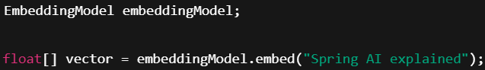

Example of working of both Chat client and Embedding model
- The problem statement is: Ask questions and get answers ONLY from those docs (PDF, doc or any other)
- Step 1: Convert documents to vectors
  - 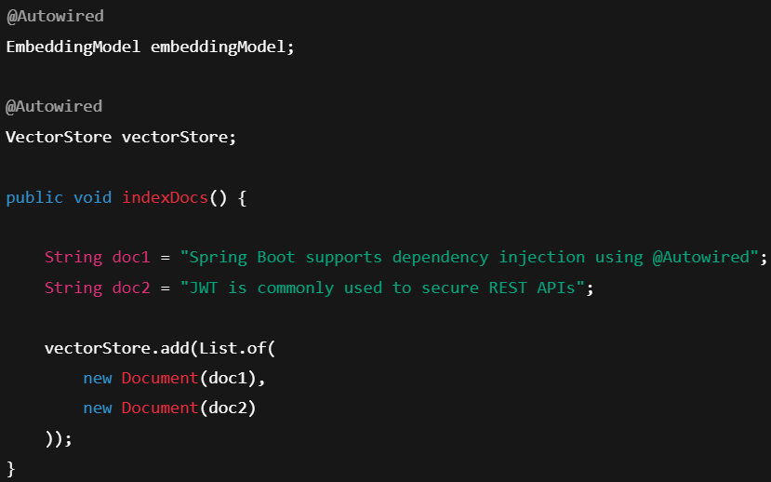
  - Behind the scenes:
Text → Embedding model → numbers → stored in Vector DB
(this happens once; indexing phase)
- Step 2: User asks a question
- Step 3: Convert question to vector
  - Behind the scenes
Question → Embedding model → vector
- Step 4: Vector search (meaning-based)
  - 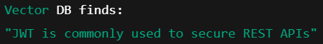
  - Keywords match: NO ❌
  - Meaning match: YES ✅
this is the exact thing vector does
- Step 5: Generate answer (ChatClient)
  - Now we finally uses ChatClient
  - 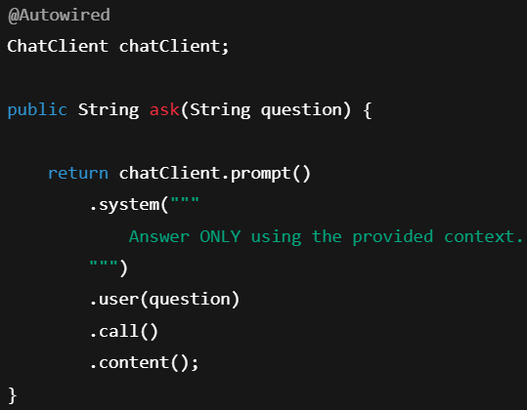
  - What actual prompt sent to LLM?
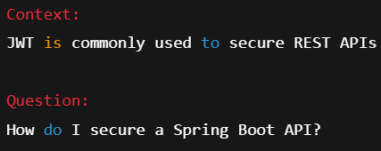
  - LLM generates
- Final mental model
  - EmbeddingModel : finds What to read
  - ChatClient : explains What was found
  - Embeddings are used to retrieve relevant context via semantic search, and ChatClient uses that context to generate a final natural-language answer.

- Temperature
  - It controls the randomness in text generation.
  - Low temperature → safe, predictable choice
  - High temperature → risky, creative choice
  - Prompt
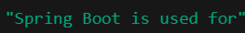
  - Temperature: 0.0
  - Temperature: 0.5
  - Temperature: 1.0
  - Temperature: 1.5+
  - 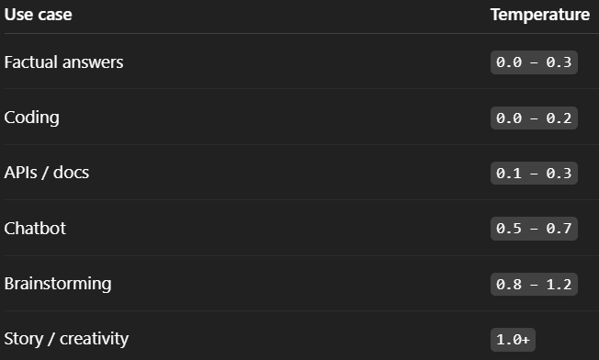
- Top P
  - Decrease the number of possibilities.
  - If Top P = x, 0 <= x <= 1
    - It’ll add the probabilities of the possible output (from high to low), and when the sum of probabilities reach x, it stops.
    - Only those many outputs are chosen out of which one will be randomly selected depending upon the temperature value.
  - Top-P limits token selection to the smallest set whose cumulative probability exceeds P, controlling output diversity.
  - Top-P = 0.1
    - Only most likely word(s)
    - Very deterministic
  - Top-P = 0.9
    - Many reasonable options
    - Balanced output
  - Top-P = 1.0
    - No restriction (because sum of all words’s probabilities will be 1)
    - Full vocabulary
- Top K
  - Top P limits the number of probable outputs according to the sum of probabilities.
  - Top K limits the number of probable outputs by its count.
  - If you give
Top K = 5
    - Then only 5 probable outputs will be selected, out of which an output is randomly choosen according to temperature.
  - Either you can choose Top P or Top K

- We’ll use Ollama here, download it and pull any AI model using the command
ollama pull <AI model name>
  - If you want to see all the models you have pulled, use ollama list command
    - 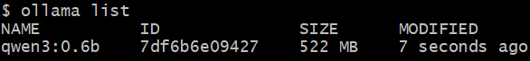
  - To run the model, use ollama run <AI model name>
    - use --verbose to get more details
- You need to configure application.properties or application.yml file
  - 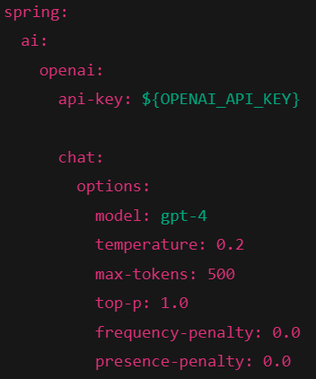 (example)
openai is the AI model provider, chat.model is the actual model to be used.
- For Ollama
  - Open Ollama settings and enable the “Expose Ollama to the network” option.
  - It is by default exposed on port 11434 on localhost.
- For OpenAI
  - Create one secret key in platform.openai.com/settings/organization/api-keys
- For ollama, you need to give the URL, for openai you need to give the api-key.
  - Remaining options you can give as you wish.
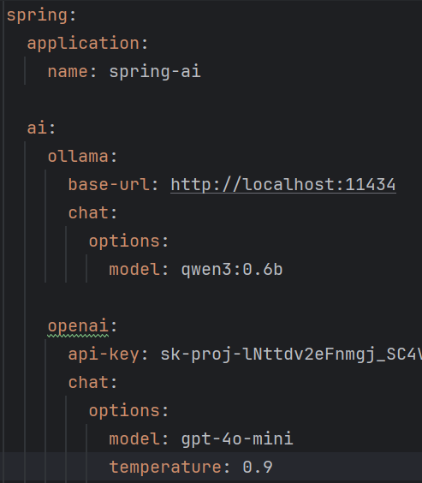
  - You need to create a bean of the ChatClient
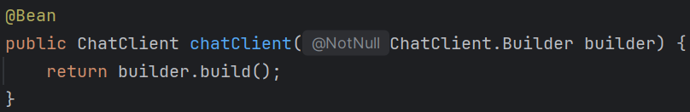
    - Depending upon the dependency, it’ll create the client.
    - If the ollama dependency is there, then chat client will be of Ollama;
    - if openai dependency is there, then chat client will be of openai.
  - 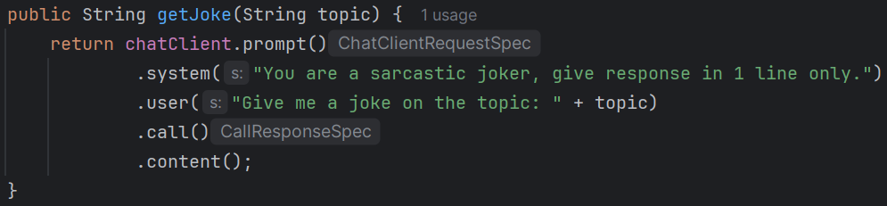
you can talk to LLM like this, system means system prompt, user means user prompt.
  - 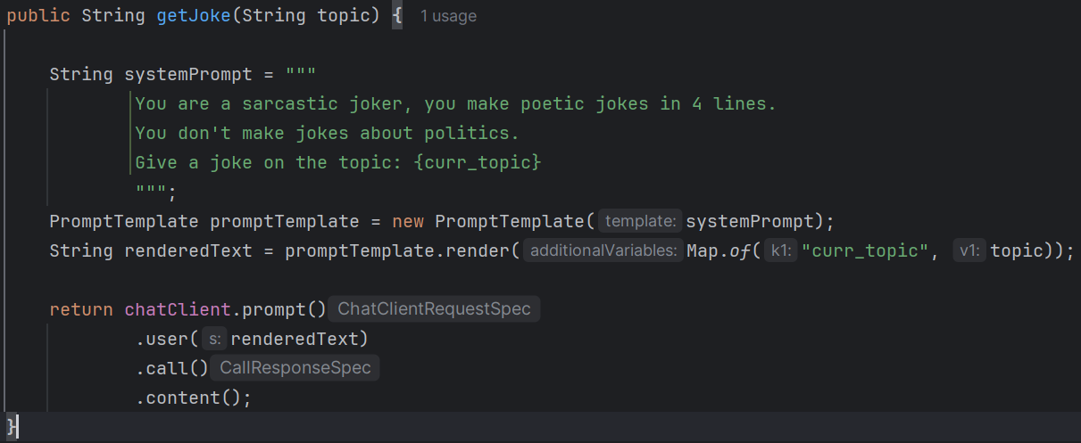
you can also use like this.
Note: key of the map (curr_topic in my case) should be same as that inside the curly braces inside that string ( in my case {curr_topic} ).
    - if you see in debugger mode, you’ll be able to see the renderedText
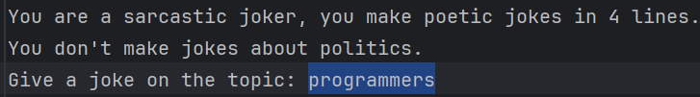
- F

- ChatModel, ChatClient in Spring AI
  - In Spring AI, the interface ChatModel present, which talks to LLM (http request)
  - For different providers like ollama, openai, claude ..etc, Spring AI contains concrete class implementing ChatModel .
You need to add the dependency for specific providers like spring-ai-starter-model-openai, spring-ai-starter-model-ollama ..etc.
  - ChatClient is a interface, which is implemented by the concrete class DefaultChatClient.
    - ChatClient contains the object of ChatModel.
    - Whatever the providers are, the ChatClient and DefaultChatClient are constant.
    - The only thing that varies is the concrete implementation of ChatModel interface for different providers.
    - it is the openai chat model
  - ChatClient just gives a good abstraction handling all the stuffs and gives you a good organized response.
  - 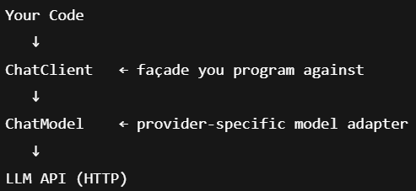

- ChatClient.Builder Auto-configuration
  - Inside the auto-configuration class org.springframework.ai.model.chat.client.autoconfigure, the ChatClient.Builder() bean is created.
  - If there is only one provider’s dependency i.e. openai, claude, ollama or something else, then it creates a bean of ChatClient.Builder class.
But in case of multiple provider’s dependencies, it doesn’t create the bean.
  - But however, you need to create a ChatClient bean using the ChatClient.Builder bean in case of single provider’s dependency.
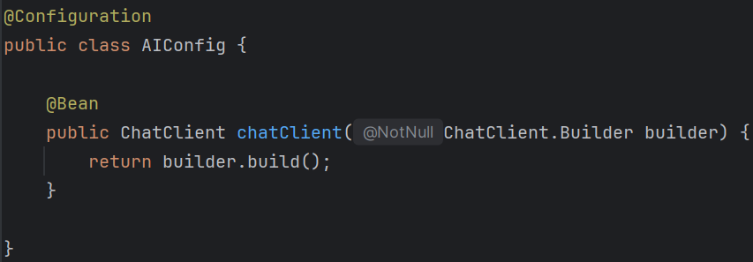
Here you are getting the bean of ChatClient.Builder because Spring AI has auto-configured this (I have given only openai dependency in pom.xml)
if I had multiple provider’s dependency, then I won’t have this ChatClient.Builder bean.
  - There is something like this
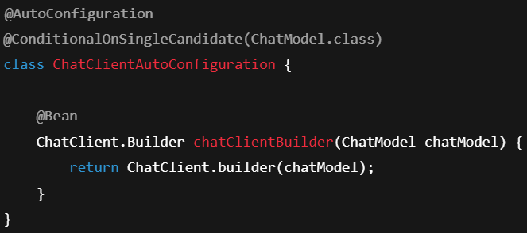
here, if multiple AI providers are there, then this @ConditionalOnSingleCandidate(ChatModel.class) will fail resulting in not creating bean of ChatClient.Builder
Embedding & Vector search
- Embedding
  - It is basically semantic compression into a fixed-size numeric vector.
The size is fixed per model and never changes per input.
  - Analogy: in color picker, RGB values are stored like for green (0,255,0), like this, the vector is represented for each text.
  - Length of this vector is called dimensions.
    - In vector (physics) we store using the dimensions only (usually 3)
  - An embedding model always outputs vectors of the same dimensionality for every input.
    - The dimensionality is decided by model, not by input length, word length, or sentence complexity.
  - 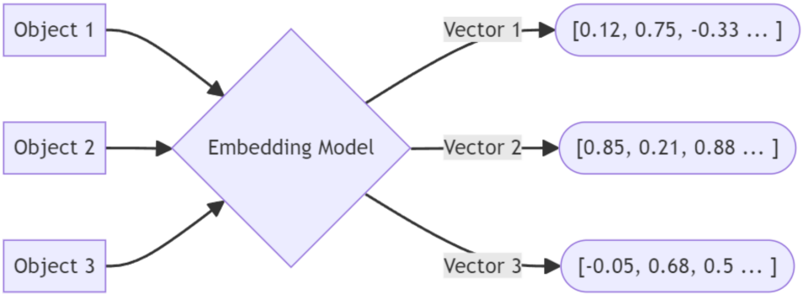
  - 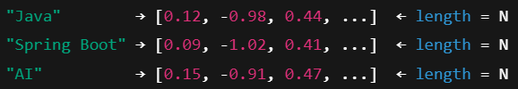
  - 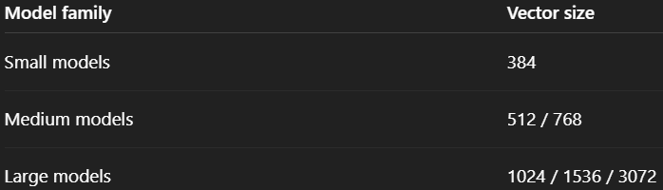
  - 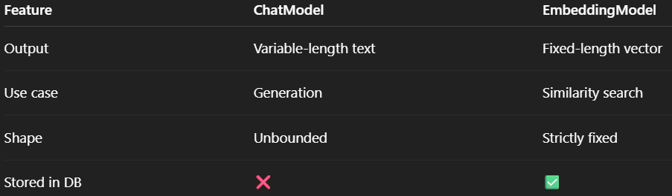
- Embedding Dimensions
  - The vector is of fixed length. Length is called Embedding dimension.
  - Each dimension is a learned latent feature.
Latent: hidden, not human-readable
    - Each dimension is a number slot.
    - The model has learned how to use each dimension during training.
  - The model learns how to distribute meaning across all dimensions.
    - Single dimension has no meaning;
    - meaning exist only in combined pattern of each dimension.
    - If you change one dimension, meaning barely changes;
If you change multiple dimension, meaning changes a lot.
  - Meaning comes from the relative geometry, not individual values.
    - Its related to previous point.
    - The model compares 2 vectors depending upon the direction, angle, distance ..etc.
If they are close, then it’ll consider this.
  - Embeddings do not store meaning in values; they store meaning in relationships between vectors.
  - Semantic capacity: ability to search by meaning
  - Don’t get confused between Embedding Dimensions and Model Parameters
    - Embedding Dimension : Size of output vector
      - 
    - Model Parameters: internal weights of neural network
      - 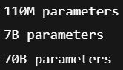

Embedding model in Spring AI
- Interfaces & Abstraction
  - In Spring AI, there is an interface EmbeddingModel and an abstract class AbstractEmbeddingModel (it implements EmbeddingModel).
  - There are concrete classes extending this AbstractEmbeddingModel for different providers.
  - 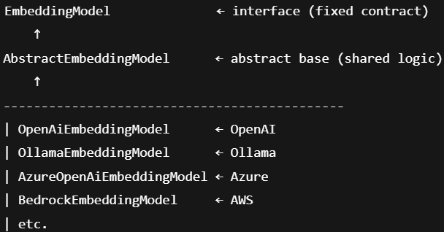
- You need to update the application.properties or application.yml file for embedding
  - 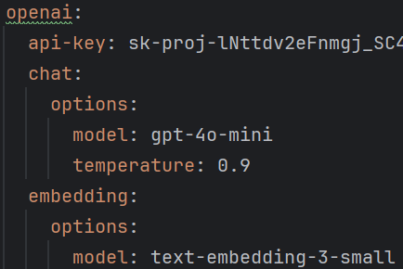
- Basic usage:
  - 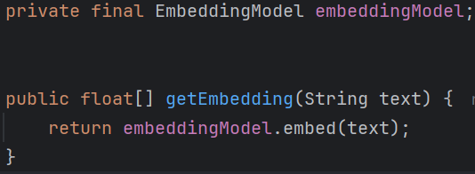
- There are database to store this vectors, which is called vector database.
These databases are not normal databases.

- To store the vectors in database, abstraction is there in Spring AI
  - VectorStore is the interface, which is implemented by the abstract class AbstractVectorStore.
    - These 2 are constant throughout.
  - Now, concrete classes extending this AbstractVectorStore are there depending upon each vector database.
  - 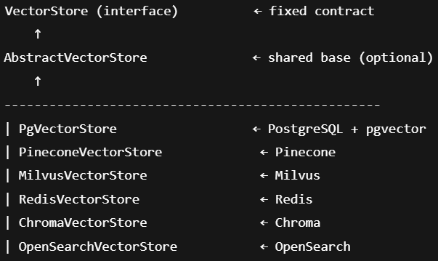
- Configuring PG vector (postgres)
  - Add this dependency
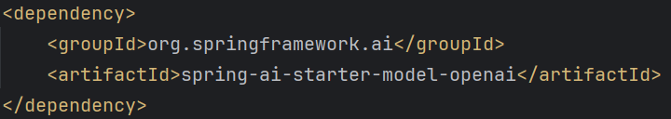
  - Configure application
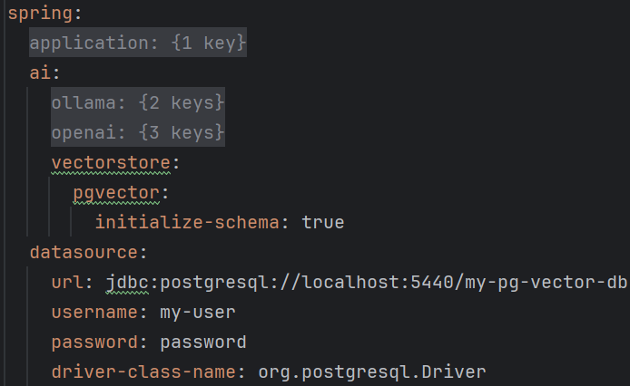
- There is one class Document by Spring AI
  - Document represents one piece of content (text) + its metadata, ready to be embedded, stored, and retrieved from a vector store.
  - 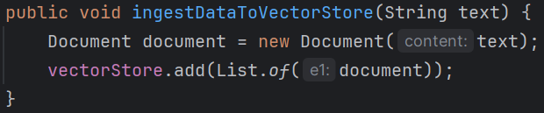
  - 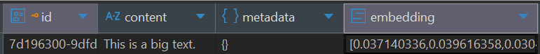
    - The embedding column will contain the dimensions.
- Adding and Retrieving data
  - I stored the following list of Document object in vectorStore
    - 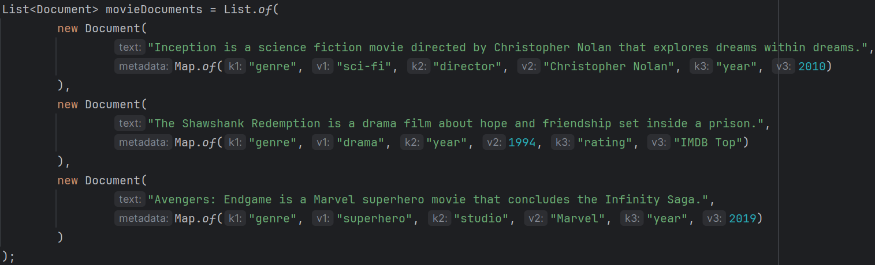
    - 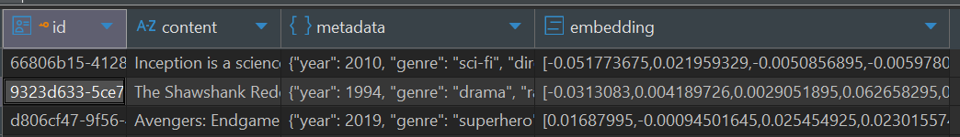
Now you can see the content (text), metadata (Map.of(…)), embeddings are present in the table
  - To perform semantic search, there is a method similaritySearch which is inside the VectorStoreRetriever interface.
This interface is implemented by VectorStore
    - It contains the similaritySearch method
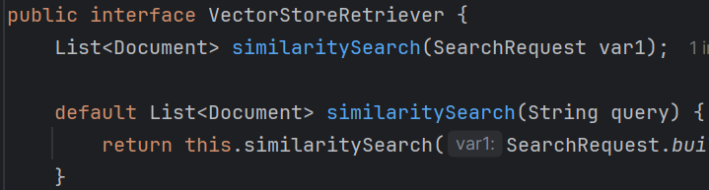
    - 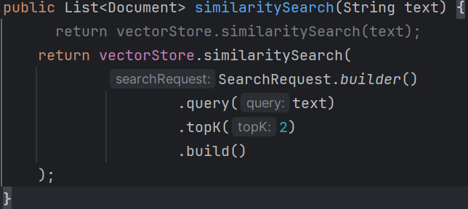
- F

RAG (Retrieval Augmented Generation)
- Lets say you are talking to the AI agent, and in that chat it knows about the previous conversations that you had earlier.
  - Or lets say you gave an AI agent (lets say ChatGPT) a pdf, and asking some questions related to that. How does it finds?
  - One solution is, along with user’s prompt, give all the content of that PDF as well, now AI model can check those contents and give some result.
Because LLMs alone hallucinate, & don’t know your private data.
But, with this approach, the tokens utilization will be very high, so it is not cost efficient.
  - Another solution is, find some relevant contents of that PDF according to user’s prompt, and attach only those content with the user’s prompt.
Now it’ll be much cheaper and optimized.
  - RAG = Retrieve relevant data + Inject it into the LLM prompt before generation.
RAG is a concept / pattern, not a concrete entity, class, or component.
    - Retrieval : VectorStore
    - Knowledge unit : Document
    - Vectorization : EmbeddingModel
    - Injection : Advisor
    - Generation : ChatClient

- RAG “ETL” Pipeline (Extract, Transform, Load)
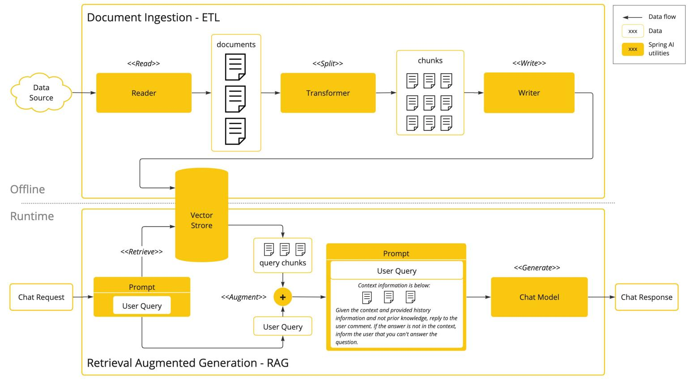
  - Phase 1 : Offline Phase : Document Ingestion (ETL)
    - Data sources can be anything like pdf, doc, db ..etc.
    - Reader will read all those documents and then transform those into chunks.
      - For example, 10 pdfs are there, they are splitted into 500 chunks.
      - Because if you embed a big document, data can be loosed as there is fixed dimension list.
    - Then convert to embed and store this in the vector store.
    - 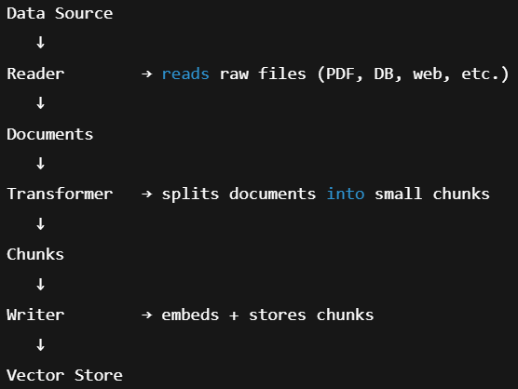
  - Phase 2 : Runtime Phase : RAG (Retrieval + Augmentation)
    - User sends a Chat request. (user prompt)
    - Attach system level prompt to that. (system prompt)
    - Then retrieve the relevant chunks from the vector store.
    - Now, along with the prompt, attach these embeddings as well to LLM.
    - Now Chat model will generate and response will be sent.
    - 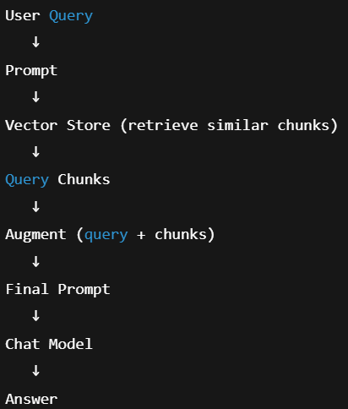
- See the below experiment
  - I just added a normal method to generate output based on the user’s prompt only.
Not attaching any other things like system prompt or something else.
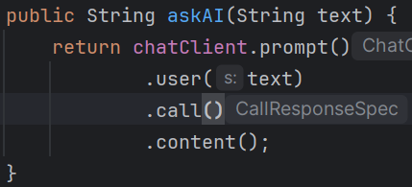
  - I told this my name
(output)
  - Then I asked it my name
(it doesn’t know)

- Now we want something that knows about us, or lets say you are building company specific agent, then it should only know about you.
  - It should not be a general purposed AI agent, it should be specialized for your company.
  - I created a dummy list of Document object
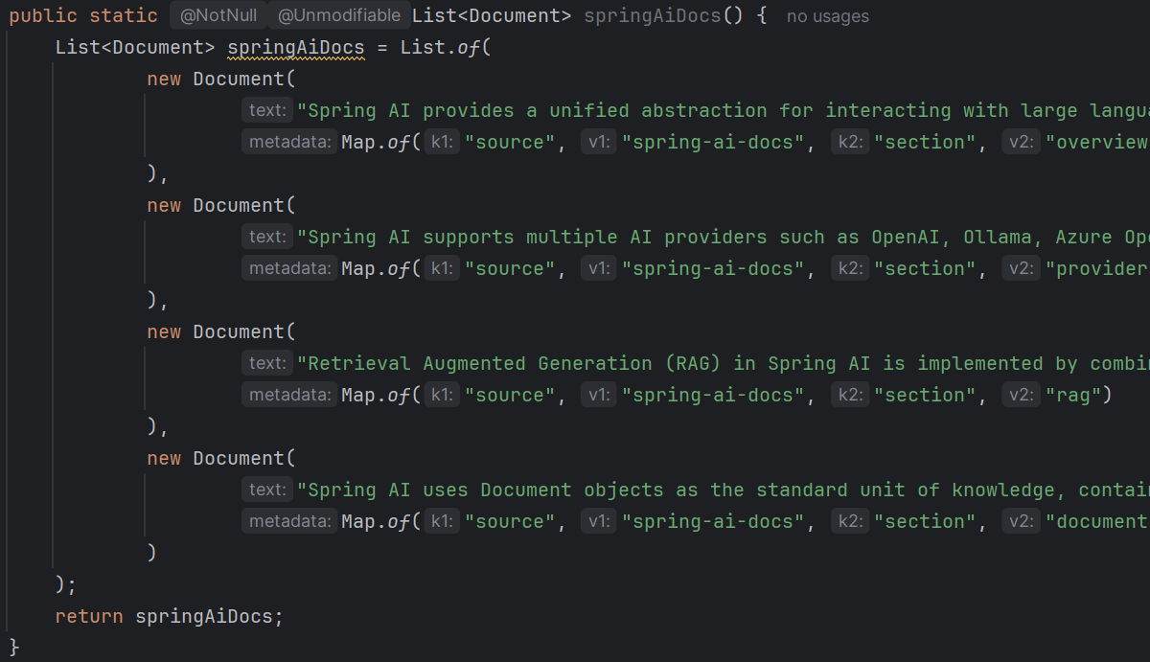
  - Now storing these documents in VectorStore
It automatically convert to embeddings and store in database
  - As the first phase (storing the embeddings) is done, now we’ll check for the retrieval and response generation part.
First create a proper prompt to tell the AI agent to use only our data, not its own data & create a PromptTemplate object out of that.
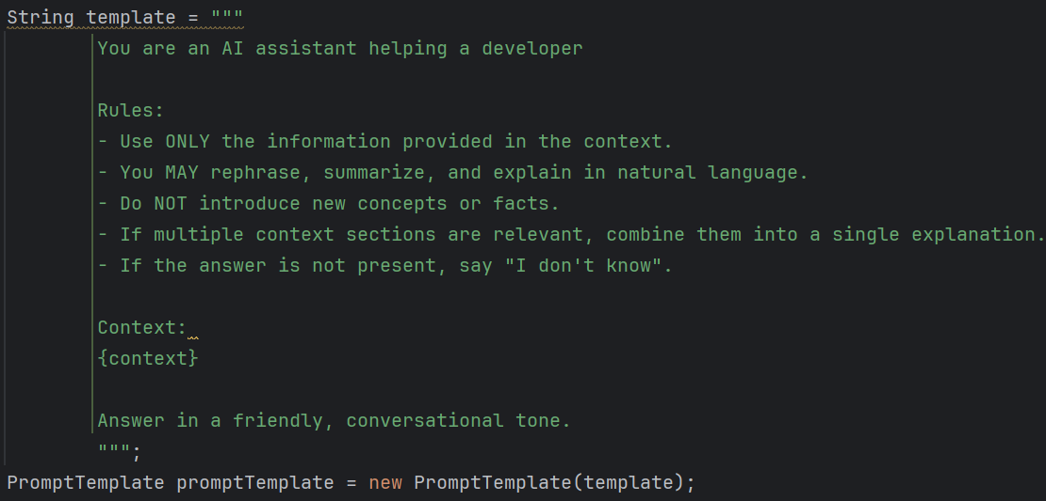
  - Now we need to give the documents as well (after fetching from the database).
I just appended the documents (from the List<Document>) and joined those as a String.
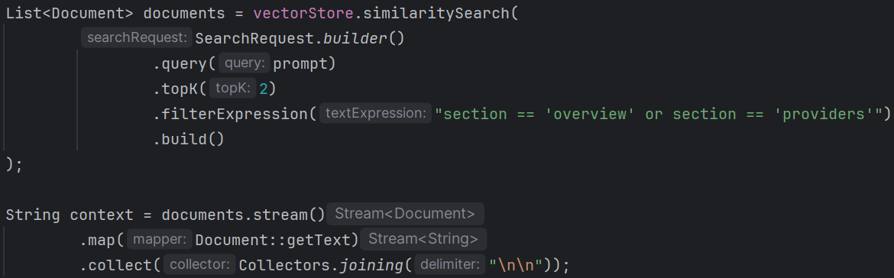
in that filterExpression block you can give the matches, these section is there in the metadata of the Documents list (you can check).
  - Now our PromptTemplate and context is ready, we just need to create a system prompt combining those.
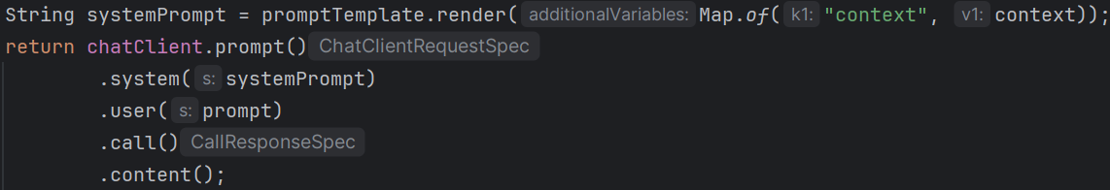
I just replaced that placeholder {context} from the template with the string version of documents list.
both user and system prompts are given.
  - I asked it now
    - “What is Apple?” ==== 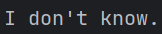
because it is not stored in vector storage, and in the rule I said if the context is not there then simply say “I don’t know”.
  - You can add advisor to do something in between. I added this to get the logs being generated behind the scene.
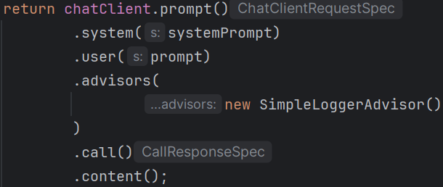

- Store the contents of a pdf and generate response to user’s prompt from the pdf.
  - To read the pdf, spring-ai has a dependency
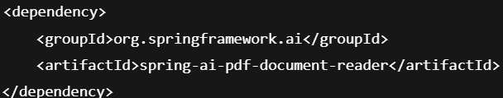
  - Everything under src/main/resources/ directory are accessible via ClassPathResource
my PDF path is src/main/resources/spring_security.pdf
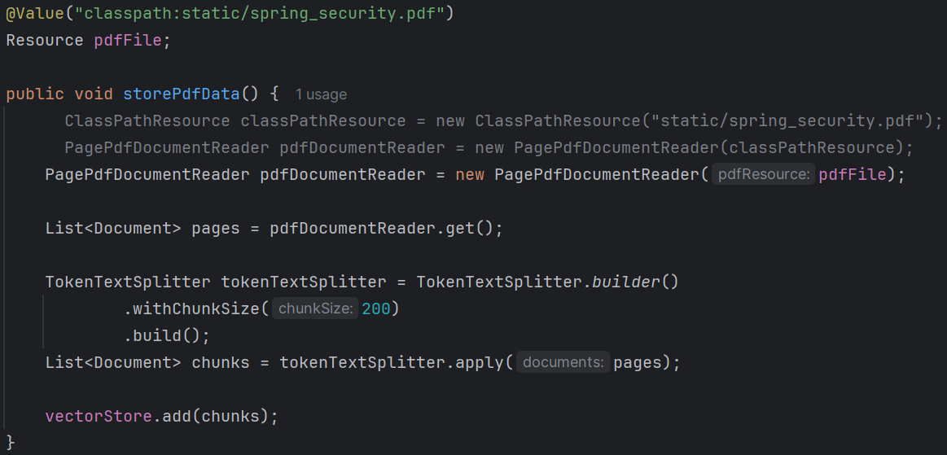
    - PagePdfDocumentReader requires an object of type Resource inside its constructor.
    - Created a object of ClassPathResource (it implements Resource) and used it to create pdfDocumentReader object. Or you can get the object using @Value annotation.
    - pdfDocumentReader.get() method returns one chunk per page by default.
    - We need to create more chunks, so TokenTextSplitter can be used for this.
    - Then stored all those documents inside the database.
    - withCunkSize(200) doesn’t mean it’ll create 200 chunks, it means size of one chunk can be at max 200.
  - To generate chatClient response, all the steps are same as before, I just changed the similaritySearch query a little bit
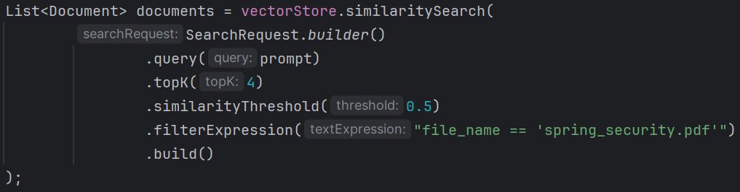

- Classes & Objects used in the process of
  - storing PDF data:
    - PagePdfDocumentReader to read the object.
    - @Value("classpath:static/spring_security.pdf") or ClassPathResource to get the resource.
    - TokenTextSplitter to create chunks with custom max chunk size.
    - VectorStore to store the data (embedding is done internally by itself).
  - ask AI & generate response
    - PromptTemplate to create a template from a String with placeholders like {context} ---- required for system prompt.
    - VectorStore to perform the similarity search with SearchRequest object.
    - [ creating system prompt from promptTemplate object by adding the String version of documents fetched from vectorStore ]
    - ChatClient to get the response by passing system prompt and user prompt.

- F
- F
- F
- F

Advisors
- Description
  - Advisors lies between ChatClient and ChatModel.
  - 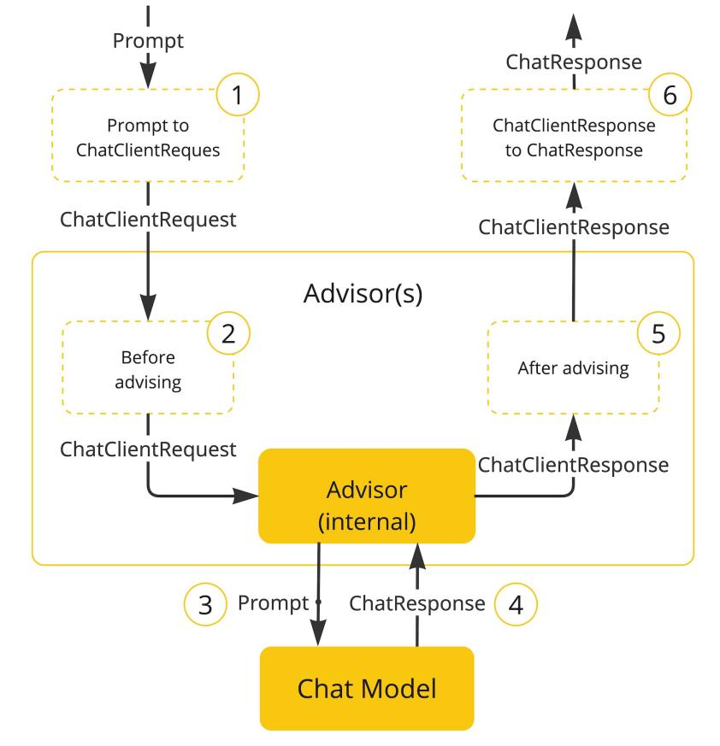
    - prompt is sent, its sent to ChatClient.
    - Now it’ll go through the advisors, then it’ll got o ChatModel.
    - After chat model gives response, it again comes via the advisors.
  - ChatClient contains a method prompt() which returns the object of type ChatClientRequestSpec.
    - This ChatClientRequestSpec contains a method called advisors
  - Advisors are not AOP proxies, these are present in ChatClient’s execution pipeline.
    - These are executed each time the call() method (present inside ChatClientRequestSpec) is called.
    - Applied before & after the model is called.

- What actually happens:
  - 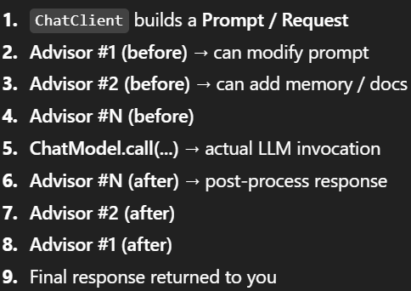
  - The order of advisors in case of ChatClient to ChatModel are reversed in case of ChatModel to ChatClient.
- Some commonly used Advisors
  - MessageChatMemoryAdvisor
    - It makes the chat stateful by injecting the previous messages into the prompt.
    - Without this → every chat is stateless → AI will be DUMBBBBB.
    - It doesn’t store the chats in vector store, it stores in a ChatMemory implementation.
  - QuestionAnswerAdvisor (RAG)
    - It fetches relevant information from the VectorStore and append those to the prompt.
    - Used in case of pdf, doc or something like that.
    - There is an advisor RetrievalAugmentationAdvisor, it does something like:
      - Takes user prompt and convert to embeddings.
      - Search topK data from the vectorStore.
      - Inject them into prompt as context and send the prompt to LLM.
      - (these are all the things we were doing manually for faq)
      - But, it doesn’t strict “ANSWER ONLY FROM DOCS”, and doesn’t have Q&A safety constraint.
    - QuestionAnswerAdvisor does everything that RetrievalAugmentationAdvisor does +
      - Strict ANSWER ONLY FROM DOCS
      - If it doesn’t find, it says I don’t know
      - It doesn’t hallucinate.
  - VectorStoreChatMemoryAdvisor (MOST COMMONLY USED)
    - Stores conversation history as embeddings inside VectorStore, and retrieve only relevant past conversations.
    - MessageChatMemoryAdvisor remembers every conversation even those are not relevant, but VectorStoreChatMemoryAdvisor stores and get only relevant to current query.
    - 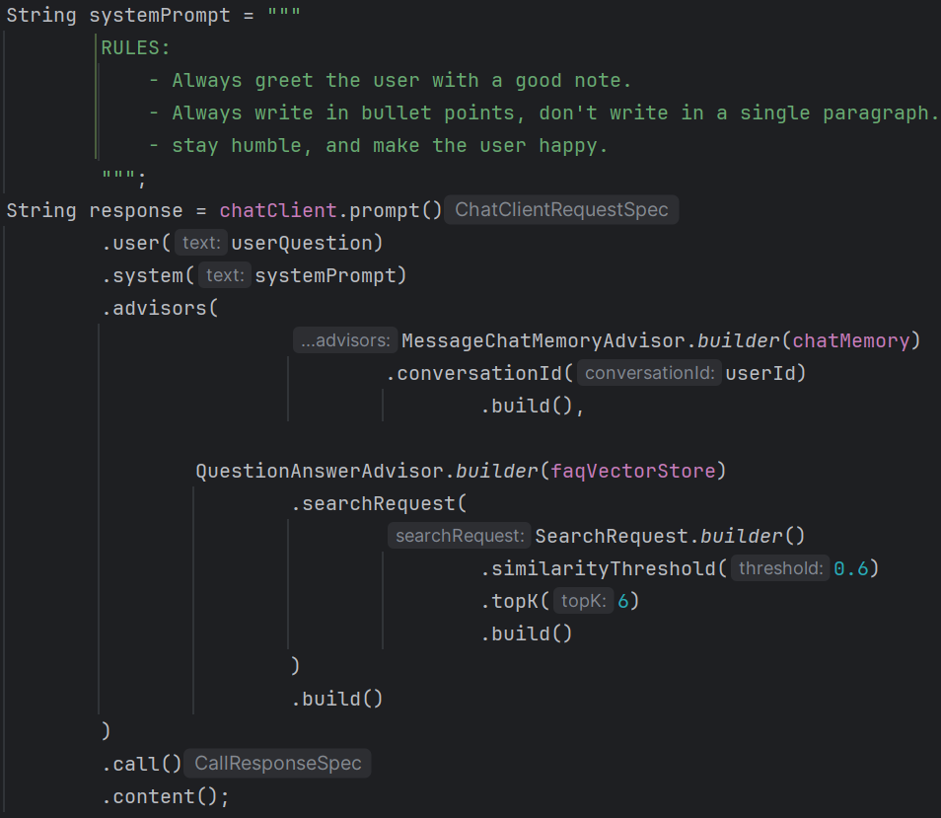
      - I used MessageChatMemoryAdvisor because it was forgetting the previous conversations.
  - PromptChatMemoryAdvisor
    - It injects predefined prompt memory like if you want to give any RULE to AI.
    - Example: system instructions, persona, rules
  - SafeGuardAdvisor
    - It filters & blocks unwanted input/outputs.
  - Custom Logging Advisors
    - Logs prompts, tokens, responses, timings.

- There is another type of implementation of advisors
  - 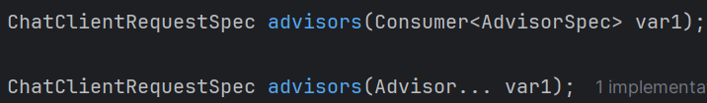
  - Previously we used the 2nd one, (Advisor… var1)
  - Another is, we can pass the Consumer type object inside it.
Consumer<T> is nothing but a functional interface that contains a method definition
  - And, AdvisorSpec is a sub-interface inside the ChatClient interface which contains more details like param, params, advisors
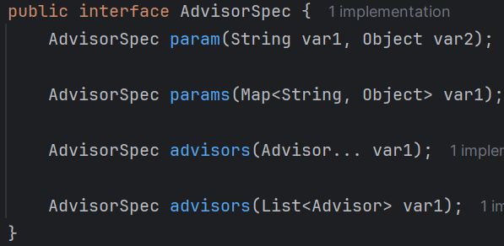
it also contains 2 types of advisors overloaded methods.
  - Simply, ChatClient have 2 types of advisors() method: one take list of advisors, another take Consumer object.
    - Also, AdvisorSpec has advisors() method.
  - This can be used like the below
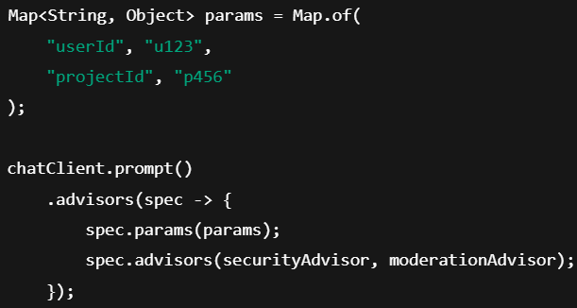
Now, this params (userId, projectId) will be accessible to all the advisors that are passed to that spec.advisors() method.

- ChatMemory & ChatMemoryRepository
  - Description
    - ChatMemory contains reference of a ChatMemoryRepository.
    - Analogy: ChatMemory is DB query tool, ChatMemoryRepository is DB itself.
  - By default, when you include spring-ai-starter-model-openai or any other AI’s dependency, ChatMemory is auto-configured and you’ll get a bean.
    - But this auto-configured bean is JVM scoped.
    - This bean is of type MessageWindowChatMemory.
      - It returns (NOT keep) the last N messages from the chat memory repository.
It is having different behaviors, in case if InMemoryChatMemoryRepository it stores all the conversations and returns only the latest N.
But in JdbcChatMemoryRepository it deletes the older messages and keeps only the latest N.
    - So, if you restart the application, the memory will be gone.
    - By default the count is 20
    - If you want to change it, create a bean of MessageWindowChatMemory and customize.
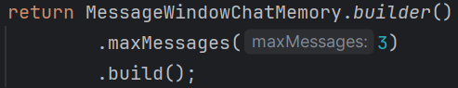
    - If you don’t provide the chatMemoryRepository while creating bean of MessageWindowChatMemory, it’ll automatically add InMemoryChatMemoryRepository
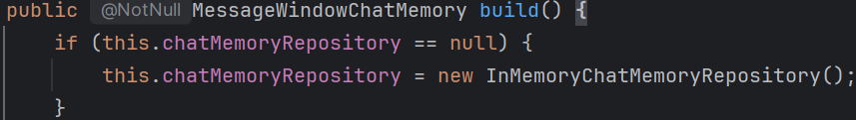
(MessageWindowChatMemory’s Builder sub-class)
  - If you want to keep the conversations permanently, across application scope, then you need to persist in a DB.
    - JdbcChatMemoryRepository uses JDBC to stores messages in relational DB.
    - If you use spring-ai-model-chat-memory-repository-jdbc for JdbcChatMemoryRepository then it’ll not provide the auto-configuration of JdbcChatMemoryRepository .
    - So, if you want auto configuration, then use spring-ai-starter-model-chat-memory-repository-jdbc dependency.
    - 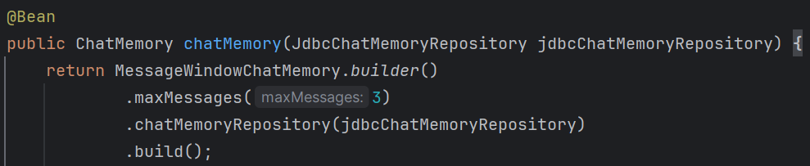
  - If you want to implement Redis or something like that, then also implementations are there. You just need to create bean of those.
    - For redis: RedisChatMemory
  - 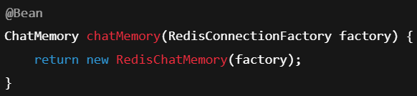
- JdbcTemplate & Datasource
  - If you manually execute the sql then multiple steps are involved like creation connection, execute SQL query, then close connections.
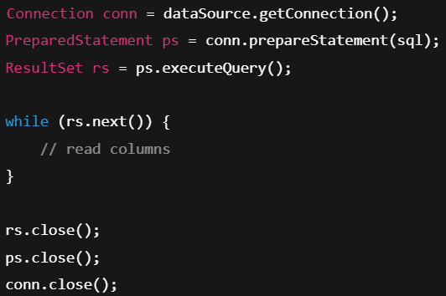
  - JdbcTemplate does all of these by itself, you just need to write the query.
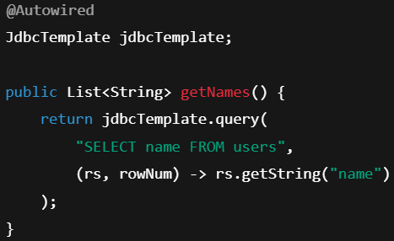
  - JdbcTemplate behind the scene does the below
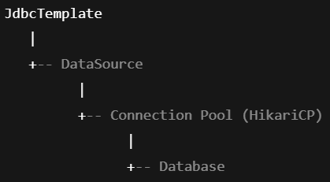
  - Datasource creates and close the DB connection for JdbcTemplate. And remaining connections are handled by JdbcTemplate itself.
    - Datasource is used by JdbcTemplate for handling DB connections.
  - In simple words: DataSource handles “how we connect”,JdbcTemplate handles “what we do with the connection”.
  - D
  - D
  - D
  - D

Using the Advisors
- You can set the default advisors globally while creating the bean of ChatClient.
  - 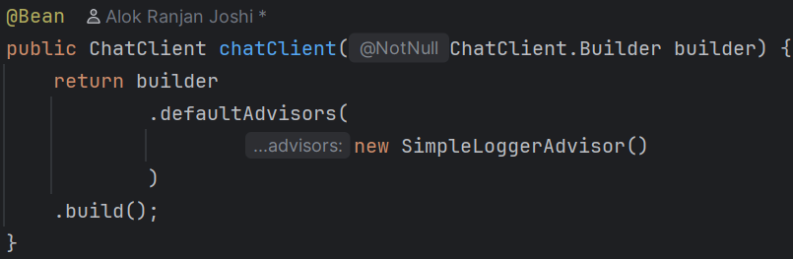
- Using VectorStoreChatMemoryAdvisor
  - 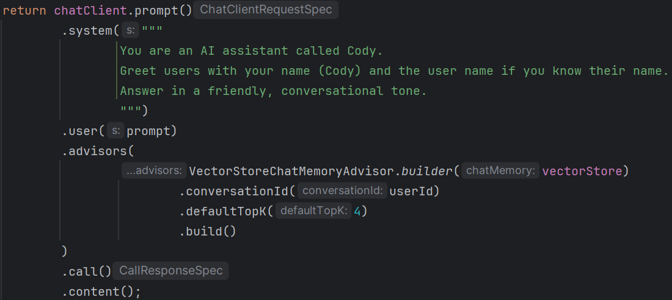
  - Here, conversationId is must, otherwise it’ll not differentiate the different chats.
  - You can see the past conversations from long term memory.
    - 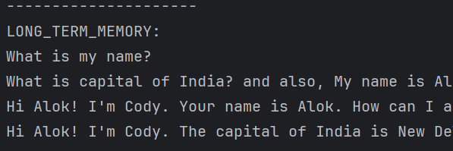
  - Also in database, you can see the entries (table: vector_store)
    - 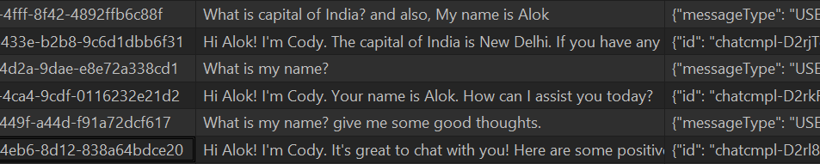
  - In this case, irrespective of the time of the message, it’ll fetch the most relevant message; but what if you want to get only last N messages.
- Using MessageChatMemoryAdvisor
  - It is a DUMB advisor, it keeps all the conversations and inject those all with the prompt.
  - But, how it gets all those messages?
    - It contains a chat memory, we can tell it to use any chat memory we want.
    - It executes chatMemory.get(conversationId) to get the messages and inject those.
    - What if we limit the number of messages in the chat memory itself, then we can achieve our goal to get only last N messages.
    - There is a class that implements ChatMemory and provides this feature: MessageWindowChatMemory
    - Whenever the advisor (MessageChatMemoryAdvisor) pushes new conversations, this chat memory (MessageWindowChatMemory) just stores that.
      - And when the advisor calls the get() method, it gives the latest N messages.
      - It doesn’t remove old messages, it just gives the latest messages.
  - Creating bean of MessageWindowChatMemory
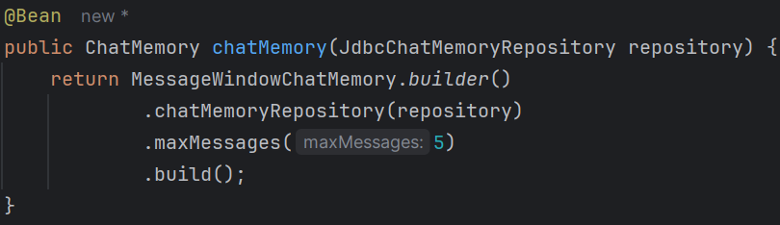
    - JdbcChatMemoryRepository is a chat memory repository.
    - chat memory is nothing but an abstraction that is used to store the data in chat memory repository.
    - chat memory has access to chat memory repository so that it can store and retrieve data from there.
  - 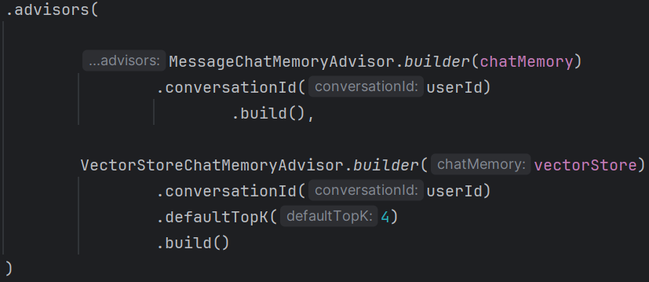
    - chatMemory is nothing but the bean of MessageWindowChatMemory.
    - This order is proper because, as the chat history is there in the prompt so VectorStoreChatMemoryAdvisor can search better.
  - As we have used JdbcChatMemoryRepository here, so it’ll store the messages in a table inside the database. If you want you can configure it to use InMemoryChatMemory which doesn’t need any table in the database.
    - 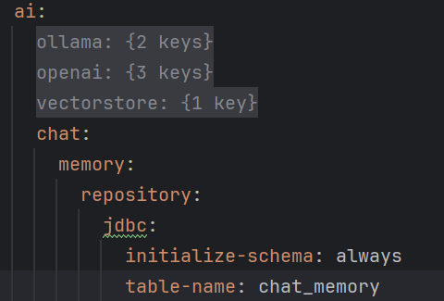
- Order of advisors
  - The order of the advisors matters.
  - The updated prompt by the first advisor will become input context for 2nd advisor and so on.

- You can also implement QuestionAnswerAdvisor for RAG (any doc data)
  - 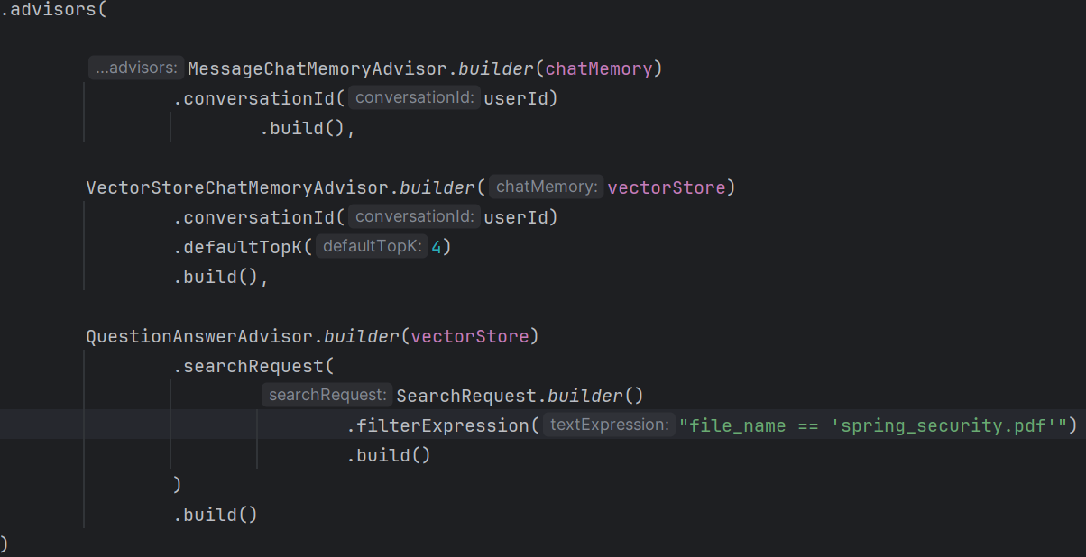

- Creating custom Advisor
- 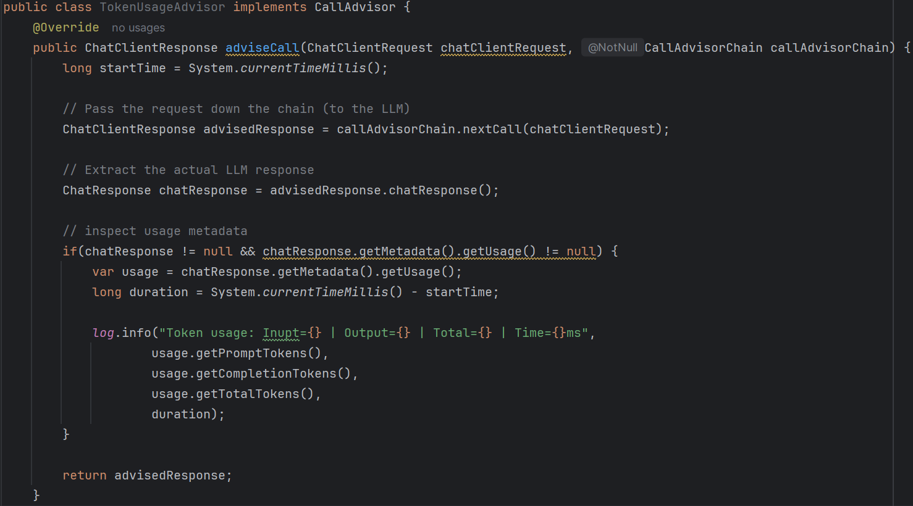
  - Create a class (advisor) implementing the interface CallAdvisor
  - It is a simple advisor just for logging purpose.
  - callAdvisorChain.nextCall() will call take the control to the remaining advisors and get back here.

- F
- F
- F

Tool Calling
- 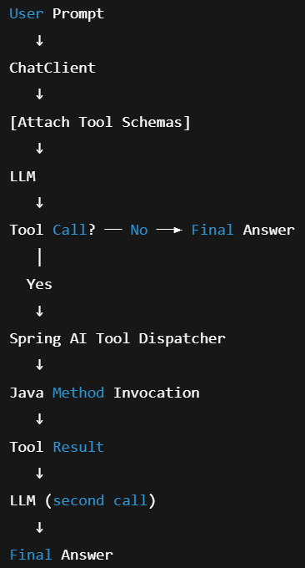
- Steps
  - You can create a tool with @Tool annotation, add this annotation to any method and it becomes a tool (provided the class that contains this method is an component).
    - 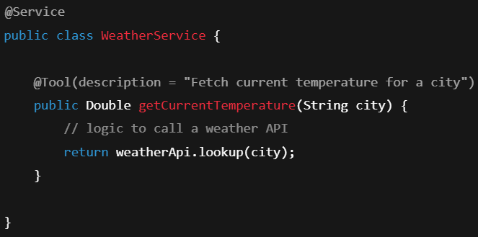
    - You can give the name, description .
  - After creating the tool, you need to attach that to any chatClient prompt()
    - 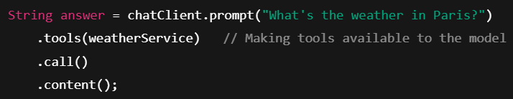
    - Note, the bean is passed to tools() here.
    - You can give as many tools as you want here like
      - tools(weatherService, locationService)
  - Now, if required, like if model doesn’t find the response in its context, it’ll make a tool call if a relevant tool is present.
    - It generates a structure like this
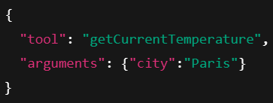
  - Now, Spring AI executes your tool method with the provided arguments and returned value is passed back to the model.
    - Now the Chat model will generate response according to that.
- Behind the Scenes
  - 1. Spring search all methods annotated with @Tools and reflect those to get the data.
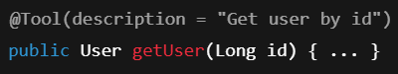
  - 2. Each tool is converted into a ToolDefinition, which is a metadata structure.
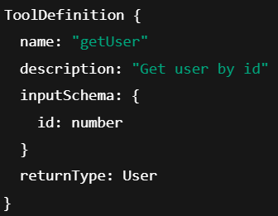
This is stored inside ToolRegistry inside Spring AI.
  - When you call the chatClient call, Spring AI extracts the tools methods from the beans which are attached to that chat client call (only the attached), and create a structure and send that along with the prompt.
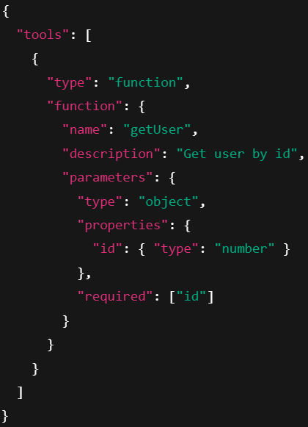
  - Now, LLM sees 2 things: user prompt, list of available tools + schemas
    - It choose one of 2 paths: either a simple text response or tool call.
    - 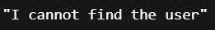 or 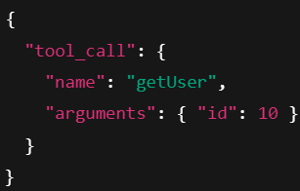
  - If LLM makes tools call, Spring AI parses the model response and finds out that it is not a normal response, and call the tool with the given arguments by LLM.
    - It might be confusing that how Spring AI is so much intelligent to parse the LLM response that accurately?
Because LLM is forced to send response in a fixed format if it wants tool call. Something like the below
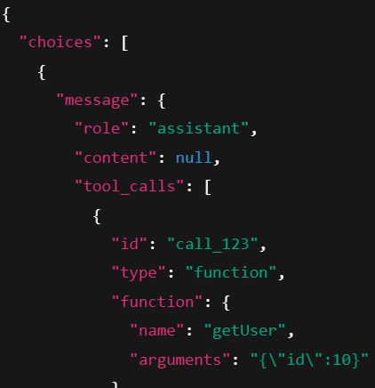
  - Now, after tool calling, Spring AI sends the response back to LLM again and LLM generate response.
- F
- F

- 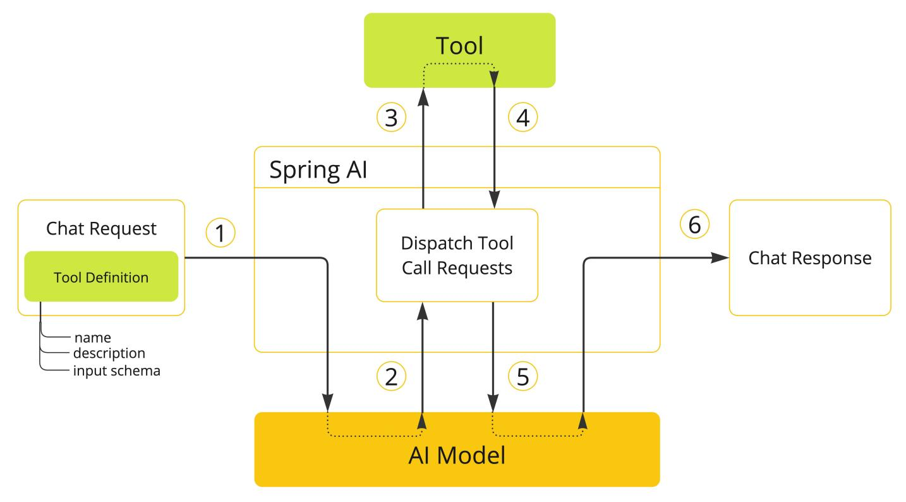
  - When we want to make the tool available to the model, we need to include this tool’s definition in the char request.
    - This definition comprises of name, description, & schema of the input parameters.
  - When the model decides to call a tool, it sends a response with the tool name & input parameters .
  - The application is responsible for using the tool name to identify & execute the tool with the provided input parameters.
  - The result of the tool is processed by application and it send it back to the model again.
  - The model will generate response with the tool call result along with the context.
  - Both ChatClient and ChatModel accept a list of ToolCallback objects to make the tools available to the model and the ToolCallingManager that will eventually execute them.
  - F
  - F
  - F
  - F
  - F

- Some specific implementations are involved
  - ChatModel contains an object of ToolCallingManager.
  - ToolCallingManager contains an object of ToolCallbackResolver.
    - This toolCallbackResolver has one method resolve() that returns an object of ToolCallback.
    - ToolCallback contains the methods to get metadata, get definition, call tool method.
MethodToolCallback implements it, and it is supplied to @Tool
    - This definition inside ToolCallback is of type ToolDefinition, which contains name, description, inputSchema of the tool method.
This ToolDefinition is sent to model.
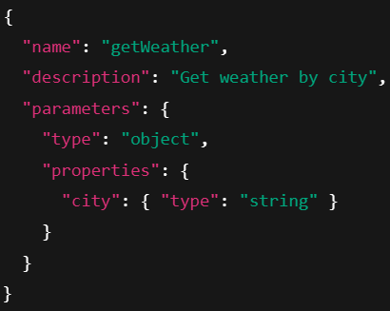
  - ChatModel calls some methods of ToolCallingManager like resolveToolDefinitions() (it returns the tool definitions) & executeToolCalls() (it execute the tools)
- Steps involved
  - 1. Tool definitions are resolved
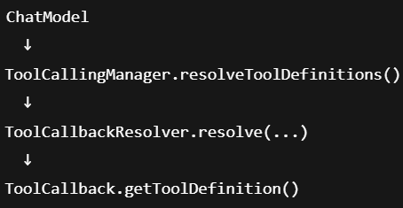
Result: List of ToolDefinition objects
  - 2. LLM Responds
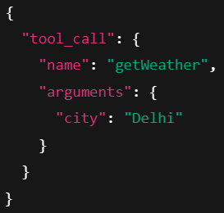
  - 3. Tool calls are executed
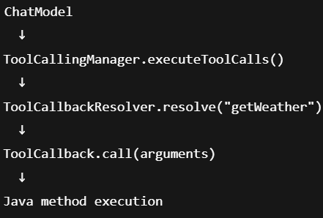
  - 4. Tool result goes back to LLM
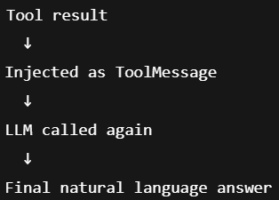
  - In a single line: LLM ↔ tool ↔ LLM ↔ tool ↔ final answer.
  - In Spring AI, ChatModel delegates tool handling to ToolCallingManager.
The manager resolves tool schemas via ToolCallbackResolver, exposes them to the LLM as ToolDefinitions, detects tool calls in the model response, and executes them using ToolCallback, which wraps the actual Java method. The tool result is then fed back to the model to produce the final answer.
  - --------------------------------------------------------------------------------------------------------
- F

- @Tool annotation
  - It contains name, description, returnDirect, returnConverter.
  - name: if not given, method name will be taken by default. Tools must have unique names.
  - description: it is used by the model to know about the method (tool). if not given, method name will be taken as description.
  - returnDirect: weather the returned result from the tool will be sent to client directly, or it’ll be sent to chat model for further processing.
  - @ToolParam annotation can be given with the method (tool) arguments to describe details about that argument like description, or if the argument is required or optional.
By default all arguments are considered as required.
  - tools are not applied globally; it is connected to the chatClient.call() whereever the tool is being mentioned.
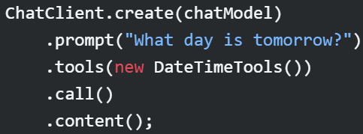
  - Under the hood, ChatClient will generate a ToolCallback from each @Tool .
  - You can also attach the tools to the ChatModel directly, it’ll be applied globally.

- Example
  - 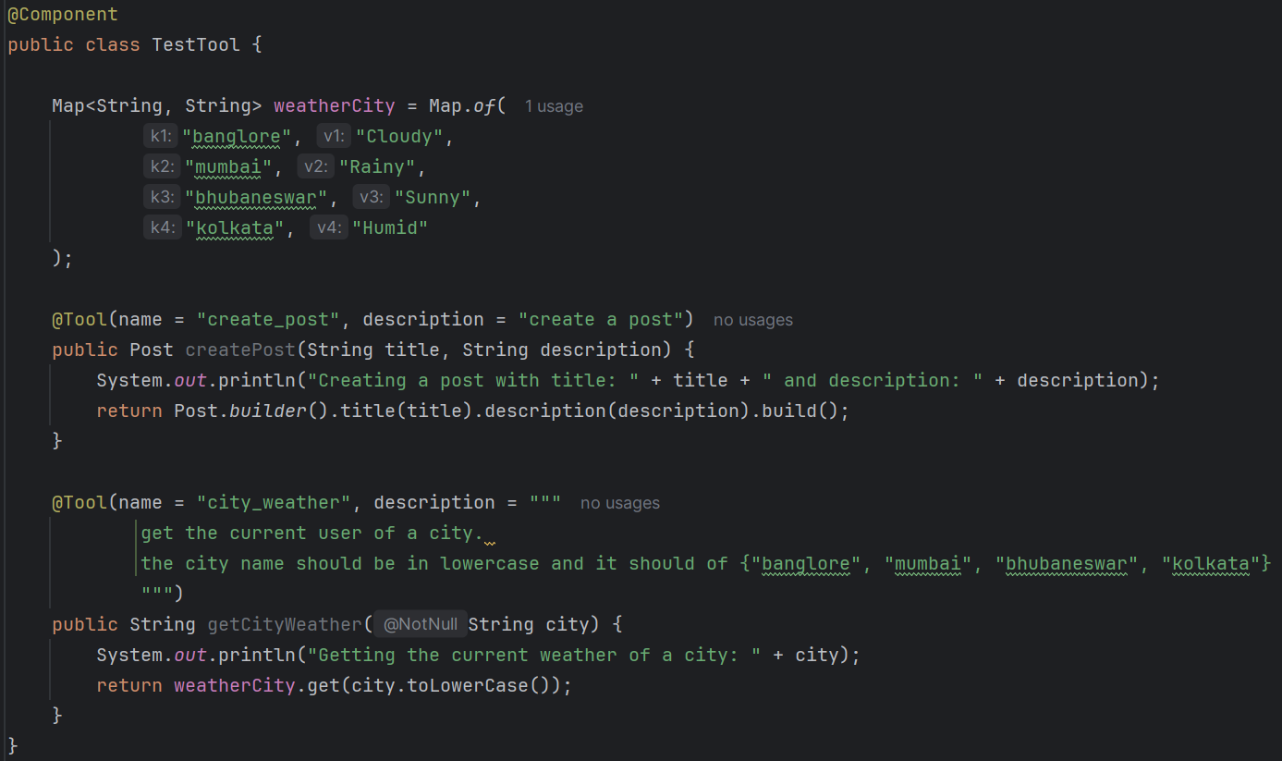
  - 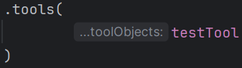 (bean of TestTool)
  - You can also give more than one tools here, it’ll work now.
- F
- F
- F
- F
- F
- F
- F
- F
- F
- F

